Espen Ytreberg

Cape Heartstone
The Travels of Nita Kakot Amundsen, Camilla Carpendale and Roald Amundsen

Translated by Lucy Moffat

Originally published as Kapp Hjertestein. Historien om Nita Kakot Amundsen, Camilla Carpendale og Roald Amundsen (Forlaget Press 2018)
223 pages, illustrated nonfiction.

Represented by NORTHERN STORIES.

Thomas Mala, Literary Agent
Thomas@northernstories.no
+47 46676155

www.northernstories.no

- Cape Heartstone

In the beginning, everything was movement for the youngest girl: grey piled clouds passing high overhead and the sound of sled runners squeaking over ice. By custom, the Chukchi used to transport small children by sleds in lace-up pouches sewn from white, brown and grey reindeer skin. She was three or four years old and lay in the pouch tucked down in the sled her father was dragging along a track beside the Arctic Ocean. Her mother had died, apparently in the first year of the child’s life. We have few reliable details from those days, but we do know the most important thing: that she was alive, down there in the sled, wrapped in the worn reindeer hides and the harsh cold. When you lie like that, breathing frosty clouds out into the Arctic winter air, the world is whisked away then gradually returns, like a wind or a wave. In the cold, cloudy weather that is customary in those parts during winter, the moisture from your breath freezes into rime on your eyes. With every blink, the white, woolly stuff that has formed on your eyelashes brushes coldly against the skin of your face.
They travelled against the wind. In winter, it blows in hard from the Arctic Ocean across Chukotka, Russia’s most easterly and northerly county. This wind almost never abates and can blow up into a storm in an instant. One minute the wind may be steady; the next, with a gust and a suck from the sea, the storm sweeps in from the north making it a battle to stay upright. The wind turns your eyelids inside out, while slanting snow and sleet fly straight into your mouth, pound your palate, seal up your eye sockets, gather in your clothes and weigh them down. The people steering the sled may have a tough job, but at least it keeps them warm. The children sleeping tucked down in the sled are spared the toil and sheltered from the wind, but they’re vulnerable to the cold. When you drive a sled day after day, there’s a steady whistling the whole time – the snow and ice sound drily against the wooden runners. Time spreads over the mountain ranges, which flatten out towards the coast, blending into the ice on the Arctic Ocean in a white expanse that is both land and sea and neither. A person lying in the sled can quickly lose track of time. When you blink or fall asleep, a moment or a day may pass.
Here she is, photographed a few months later. She was sleeping then, too.

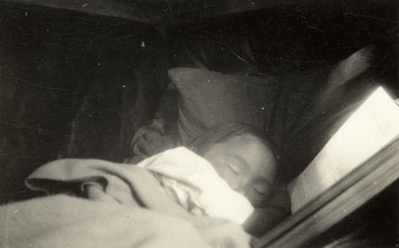

Taking the youngest girl, the father left the area around the Neshkan settlement he came from and where the girl’s mother had apparently died. The Chukchi generally travelled by dog sled. Kakot must have been badly off, as he was pulling the sled himself. Some time in summer 1920, the father and the youngest girl arrived at a family tent by the coast where some relatives lived. They were allowed to live in the tent for a while. In the autumn, the father then left the youngest girl with the family in the tent, to go and look for work. This is the first time the sources tell of the girl being handed over to other people by one who was close to her. The father sought work on a ship manned by people from the West who passed along the Arctic coast now and then. Some time in the second week of December 1920, her father reached the ship. There, he presented himself to the crew as Kakot. This is how he ended up in their written accounts, and how we know his name. Under this name, he entered their accounts. They also took photographs: the one above of the youngest girl, and the one below, of the coast by the Arctic Ocean.
At this time, the ship lay frozen into a little bay right beside a bare, round-backed mountain that projected into the sea to form a headland. This marks the spot where the Siberian coast bends southeast towards the Bering Strait, that short stretch of sea separating the Asian and American continents. Some months later, one of the ship’s crew took a picture of the headland seen from the east: a ridge of black rock out to sea, like some great, silent sea creature on the surface, half-buried in ice. By then spring had come, but the sound still lay tightly packed in broken-up drift ice. Today, the maps use the Russian name for the headland: Serdtse-Kamen. In English it means Cape Heartstone.

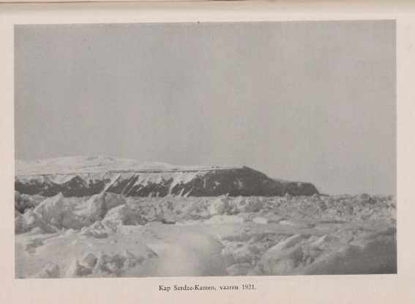

Early in spring 1921, the oldest girl was driven along the same coast in another sled and got to see the headland from roughly the point where this photograph was taken . She was around seven years older than the youngest one, eleven or twelve years old. She had recently taken leave of her parents to travel to the ship and live there. None of the crew knew her at that time and neither did the youngest girl. The oldest girl knew it would be a long time until she went home again, but not just how long.
She was big enough to sit upright in the sled, hold on tight and watch the landscape rising up before her. By the Arctic Ocean, the shapes of the landscape are few and vast. Mountains like Serdtse-Kamen form looming, geometrical figures, ending on the southern side in infinite, flat tundra. The ocean is one massive block of grey from shore to horizon, once in a while blinding blue. In winter, everything is white, land and sea blending into one. There are no trees in these parts. You have to look down for signs of life: sled tracks or bird prints in the snow.
Along the coast in these areas of Chukotka lie some peculiar landscape formations. On the flat areas along the coast, narrow sandbanks run parallel to land, creating lagoons. The sandbanks are connected to the mainland at both ends. They form an extra set of coastal strips, exposed to the waves that almost always crash and the wind that almost always blows hard from out at sea. This still photograph from the end of one such sandbank is from a film recorded a few years after the two girls passed through. To the left of the sandbank is the Arctic Ocean; to the right, one of the lagoons along Chukotka’s northeast coast.

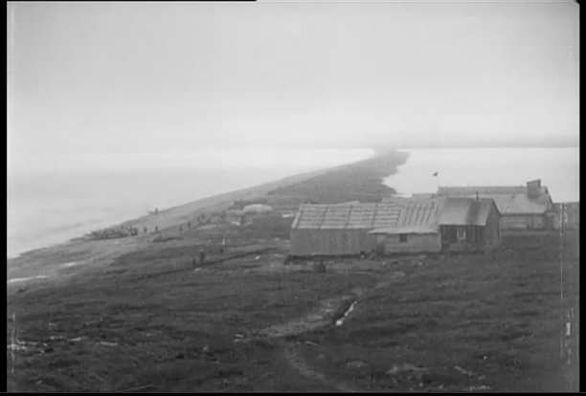

The sandbanks brought the travellers out to the point where everything merged – land and sea and sky. The only foothold here was coarse, pale grey sand mixed with thousands of small splintered fragments of wood from trunks that had drifted north along the great Russian rivers long before.
Footing is precarious here and it is an exposed place to stand. People crossing these sandbanks tower in all that flatness; the weather strikes them, unprotected. But once in a while, generally in the summer, a traveller may find it grows bright and the wind drops to a low whistle. Then all distances seem much shorter than they are. A person standing out on the sandbanks can see infinitely far out to sea, northward towards the pole or east across the Bering Strait towards the American continent.

- Amundsen

For European men who travelled east from Finnmark to the Bering Strait along what they called Northeast Passage, the coast of Chukotka seemed first and foremost to be infinitely desolate and monotonous. The land that gradually emerged to their starboard appeared merely to be a flat and icy plain, a foundation and no more; just a streak visible against the horizon until you came right up close. The tundra stretched out like a blank page, the same from horizon to horizon, from least to largest. “This is the entrance to Asia’s extraordinary, endless flat land,” the explorer Fridtjof Nansen wrote about his first impressions of Siberia, “so different to everything we are used to.”
And yet they came, wave upon wave of them across the centuries. Their names are now attached to islands and straits along this expansive part of the world: Barents, Bering, Nordenskiöld, von Wrangel. From the late 1800s, Norwegians led the way in exploration of the Northeast Passage. First out was Fridtjof Nansen, with his ship, the Fram. He sailed east to the New Siberian Islands in 1893 and from there he let the Fram drift north with the ice across the Arctic Ocean. In 1918, the expedition-leader Roald Amundsen followed the same route eastward in the Maud, with a crew of nine. Among them were the scientist, Harald Ulrik Sverdrup, Oscar Wisting and Helmer Hanssen. They needed to get at least as far east as Nansen had travelled, seeking the exit point where the drift of the ice would carry them straight over the North Pole. The Maud left Vardø on 18 July, crossed the White Sea east of the Kola Peninsula and followed the coast of what, in that revolutionary year of 1918, went from being Russia to the Soviet Union. They were supposed to reach the North Pole, carry out scientific mapping and perhaps find new land.
The most constant problem for the Maud expedition was the ice, and the risk of being frozen into it. North of Siberia, the season of open water was short, limited in practice to the brief summer. Even then it was always uncertain where the ice lay and how it was moving. In the best case, it kept out in the Arctic Ocean, enabling a ship to follow the northern edge of the Asian continent. In the worst case, the ice cover extended all the way from the shore northwards beyond the horizon, sealing everything in. Therefore, people setting out from Norway by ship to travel far to the east had to monitor the temperature and weather conditions daily, as they altered in unpredictable ways, from mist to dense snowfall, wind and bright weather, the way it is in polar coastal regions. The world around them shifted capriciously between motion and stagnation: they never knew quite whether everything around them would freeze into absolute motionlessness or break up in the next moment, in an hour, or a week, or a winter. On ships like these, the crew made a habit of always listening out for the sound of the ice breaking up: on deck they would gaze around to keep track of the low land. They needed to keep their senses alert to whether the wind was rising or abating, even when they slept.
After a week, they reached the sound between the mainland and the great islands of Novaya Zemlya. By then, ice floes had already settled around the ship some time before, rocking on the surface. For some days, they sailed among the floes that gradually compacted into a layer of ice with open channels through which they pounded a passage. One bright morning on 22 July 1918, they stood on deck looking out across the sound and were forced to acknowledge that their way was blocked for the first time by tightly packed ice, the whole length of the horizon from Novaya Zemlya’s southernmost island across to the low mainland.
Other than the ice, Roald Amundsen’s special concern at this time was the telegraph. The telegraph station on the landward side was in daily contact with a network of stations further east in northern Siberia. Amundsen had heard promising news in the latest telegrams the station had received: the sea was clear of ice further east, even though the stretch straight ahead was frozen over. The telegraph was more to Amundsen and the other Norwegians than just a source of information about ice. In a broader sense, it guaranteed them control over an extreme and ungovernable natural world. It was an existential reassurance. The telegraph erased time and space, in the sense that the technology offered almost real-time contact with people who were an extremely long way off. It conquered the infinity of Siberia almost as swiftly as human thought. The ice turned the world into a frozen expanse where the men were overwhelmed by the distance that made prisoners of them. The telegraph turned the world into a round ball across which one could move like a cloud: calm, yet also lightning fast and effortless.
But there was a great distance between each telegraph station and, in between, the Norwegians had to grapple with the unpredictable rhythms of Siberian nature, as well as its enormous distances. The next day, those on board the Maud woke up to find the ice-masses in movement throughout the sound where it opened up towards the east. The ice floes headed north, hissing, creaking and whistling; they rose and sank rhythmically upon huge, slow billows. On board the Maud, they cast off as quickly as possible, and sailed east across the sound. Along the way they tacked between ice floes and small islets in the shallow strait, marked with cairns placed there long before by people unknown.
For one brief month, they managed to avoid the ice – but found no open channels either. In mid-September 1918, they had to abandon the idea of getting any further and prepare to overwinter at Cape Chelyuskin, the northernmost point on the Siberian coast. The Maud was well and truly stuck: the ice blocked all ways forward. Next year, the same thing would happen. They were locked into the ice just a couple of months after the thaw had set them free. In 1920, it happened for a third time without their being able to reach the point of departure for a drift across the Arctic Ocean. They were frozen into the ice close to Cape Heartstone, entering their third winter of stagnation.

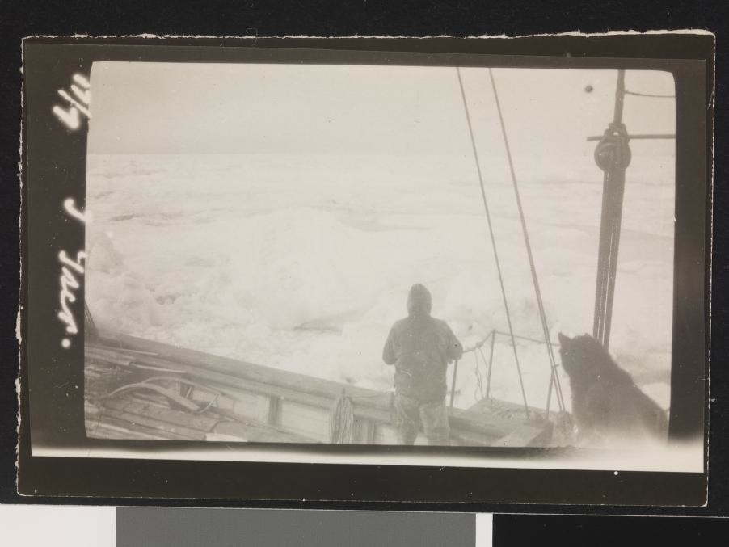

This photograph was apparently taken in autumn 1920, around the time when the Maud was frozen in for the third year. While the telegraph pointed out towards the big, wide world outside, the photographs from the ship give an impression of that frozen time in the winter ice. When the ice first forms along the northern coast of Siberia, it can wipe out the difference between land and sea. It begins between the ridges beside the coast and stretches out towards the horizon. For the person standing on the deck of a ship that has been frozen in near the coast, it is impossible to see whether the piled ice breaks up as it meets the sea at some point further north or stretches, unbroken, all the way to the North Pole.

*

Until the Maud sailed east, Amundsen’s career and fame had long been on a steep upward trajectory. In 1906, he and the crew of the Gjøa were the first to complete a voyage through the Northwest Passage, from Hudson Bay through the desolate archipelago of northern Canada to Alaska. In 1911, his international fame peaked when he became the first person to reach the South Pole. Amundsen was an internationally renowned explorer and a media celebrity. He also won recognition for his research and was a source of pride for newly independent Norway: a masculine ideal people could strive to emulate.
The Maud expedition along the Northeast Passage marked the end of this period of success. In late summer 1920, Amundsen had to acknowledge that three years had passed without their even reaching the point where the northward drift across the Arctic Sea was supposed to begin. In addition to the constant problems with the ice, several serious misfortunes befell Amundsen. Late in September 1919, he fell off the Maud’s gangplank and broke his arm in several places. Some weeks later, he was attacked by a polar bear out on the ice, hurled to the ground and clawed bloody before the crew shot the bear. In December, Amundsen spent too much time in a magnetic observatory they had built. The observatory was packed into a thick layer of snow and lit up inside with a kerosene lamp that gave Amundsen carbon monoxide poisoning.
For the rest of the winter he was plagued with heart problems, a high pulse rate and breathing difficulties. Amundsen had been a strong and tireless man all his life. Much of his sense of self and self-confidence were connected to his physique. All these misfortunes befell him when he was 47 and age had begun to make him more vulnerable to physical stresses. The incidents combined to cause Amundsen lasting physical damage. For the rest of the expedition, he suffered with a right arm that had become shorter than the left, deep scars on his back from the polar bear’s claws and a heart that whispered to him from time to time that something was still amiss.
While Amundsen was partly incapacitated, discontent spread among his crew. His earlier expeditions had not been free of conflict, especially not the preceding one to the South Pole. Even so, the unifying forces were weaker now and the divisive tendencies more obvious. The crew had to deal with much longer periods of waiting than on the South Pole expedition, had less to fill their time with and had more alcohol available to light a fire beneath the conflicts. They increasingly got on each other’s nerves. While the older crewmembers became moodier and crankier, the younger ones became more insolent and impolite. Amundsen reacted by retreating: he sat alone, reading or writing, while the others sat together in the evenings. In late summer 1920, Amundsen’s goal of reaching the north pole was still far off. His ambition of drifting across the Arctic Ocean held firm, but in a letter home to his brother Leon, it had become something he clung onto regardless of what seemed genuinely possible:

If only I myself had been healthy, I would have paid no mind to all this unpleasantness, but unfortunately, I am probably the one who should have travelled home before any other. My hart is not as it shud bee and does not permit mee many leaps and bounds. I resist it as best I can, but you know – the coald, the lack of sun and the great responsibilities – will certainly soon finish their work.

“Hart” is heart, “coald” is cold. In recent years, Amundsen had taken to spelling words in his own quite particular way, almost phonetically. It gave a kind of intimacy to his journal and the letters he wrote to friends. At the same time, it is somewhat unusual to write phonetically like this in letters to others. It is possible that this writing points towards an obstinacy in Amundsen, a tendency to reject the demands of the people around him. The letter to Leon had an introspective tone; Amundsen wrote about his inner demons: the loss of physical strength, the lack of progress in both the expedition and his life, the loss of control over himself and others. Finally, death. The year before, Amundsen had been happy to see a kittiwake flying from the south as summer approached and wrote in his book The Northwest Passage about “the life it has brought with it, up to this kingdom of the dead”. Some years before him, Nansen had described the experience of being frozen into the Siberian ice as a “slow death”. The endlessness, the stagnation, the desolation and the colourlessness: so many aspects of the Siberian winter steered your thoughts in that direction.
Nansen’s and Amundsen’s formulations were not just personal expressions of pain and death drives. Western explorers and people of letters had written about the polar region in this vein for a long time. It was just as much a matter of literary tradition as an expression of spontaneous emotion. The literature about the Polar regions often centred on weakening, madness and death, but it also conveyed experiences of conquering nature and transcending one’s own limitations. At this time, Amundsen was not just thinking about stagnation and death but also about new forms of life-giving mobility. As early as 1914, he had taken his flying certificate – the first Norwegian civilian to do so. While he overwintered on the Maud, Amundsen’s thoughts turned seriously to flying. He had started to think about the possibility of exchanging ships and sleds for aeroplanes and airships. Air travel made it possible to achieve tremendous speeds that conquered seas and continents in a matter of hours or days rather than months and years. In several sections of The Northwest Passage, Amundsen described how the northern lights in the Siberian nights could erase the colourless monotony of the days. During the clear winter nights, vertical pillars of yellow, green and red billowed out of nothingness and filled the heavens. For the northern lights, nothing is remote. One minute they are nowhere to be seen, the next they are dashing in a rush of colour from one end of the world to the other.
It was during the third overwintering that Kakot came to the Maud and got a job on the ship. Just before New Year 1920, he obtained permission to leave the ship for a few days. He travelled to fetch his daughter, then still living in their relatives’ tent.

- Nita

When 1920 gave way to 1921, Kakot fetched the youngest girl from the family tent. We do not know exactly how long she had spent there, but it was several months, long enough for a little child to feel at home. The Chukchi tent was a little world that contained all the most important things: food, company and heat. Once the Chukchi tent had warmed up, the temperature in its inner room could rise to well over twenty degrees above zero. Then the adults would strip to the waist, and the bigger children might wander round more or less naked. A person entering the tent, chilled through from the day, eyes wearied by the daylight reflected in the snow, would have all their senses assaulted: the smell of smoke and people, the steam from the pots wafting forth the scent of reindeer meat, the murmur of people going about their regular evening business, the yellow light and reek of the fish-oil lamps. As they slept around the tent, its warmth and humidity made people cough in their sleep.
It was easy to catch a cold on your way between the dry cold and the humid heat of the tent; the Chukchi children were constantly sniffling. If you were weak, your illness might take a turn for the worse. Then the Chukchi were in trouble, in a region where the margins of survival were narrow, where famine could quickly gain a foothold and where nature attacked the weakest first. In 1920, famine was threatening because there was little game to be found on the north coast of Chukotka. The more people there were in the tent, the sooner the stocks were exhausted. Traditional Chukchi hospitality made it possible to come and live with them, but when food was scarce, it was difficult to stay. Apparently this was one of the reasons why Kakot first travelled alone to seek work on board the Maud and then came back for his daughter. Her body was also dotted with eczema of a type that troubled many of the Chukchi children.

*

How would it have felt for a four- or five-year-old Chukchi girl to be carried on board a Norwegian ship? When the Inuit people on Greenland first saw Western ships in the 1800s, one of them described the sight as “whole islands of wood that moved on the water with wings and which had many houses and rooms filled with loud-voiced people deep within them”. When the youngest girl was carried on board the Maud, she would have experienced for the first time the way everything around one could shift slowly on a ship, even when the sea was calm and the ship lay at anchor. She would have smelt the pungent stench of tar and diesel oil, heard the creaking in the woodwork that big ships make when sea ice presses against them. The shapes around her on the ship must have been strange and unusual, the sounds too: those of people and those of things, the one indistinguishable from the other.
At some point we know that she was lifted up by her father Kakot, out of the bundle of hides in which she lay on the deck of the Maud, up in the cold winter night to be passed over to another man. The eczema that covered much of her body probably made it painful to be lifted like that.
In his autobiography, My Life as a Polar Explorer, Amundsen told how he heard that Kakot was back with his daughter and went up on deck to them. Amundsen recounted what happened as follows:

“Where is the child?” I asked.
He pointed at the deck, where a bundle of hides lay under the bulwark.
“Come here with it,” I said.
Kakot picked up the bundle and placed it in my arms.

Before relaying this scene, Amundsen had written nothing about Kakot other than that he had worked on the Maud and then asked to be allowed to go away for a while to fetch his daughter. Until then, nothing was written about her, or about any arrangement or negotiation between Kakot and Amundsen. The passage is strikingly brief: Amundsen sees the girl, proposes to take charge of her, gets his way. How could he express such a wish to the father, so abruptly and imperiously, apparently without warning? And how could Kakot go along with this at once, apparently without protest?
My Life as a Polar Explorer was written six years after the handover of the little girl. That is a long time. We do not know how accurate Amundsen’s account is. In his autobiography, Amundsen describes the handover as if it were a myth, a story from a fairy tale or the Bible. It is far from certain that he was, in fact, so direct and commanding, apparently without cause. It is also possible that Kakot was not so wordlessly accommodating either. One little detail in the dating suggests that the handover of the little girl was nowhere near as rapid and imperious as Amundsen’s autobiography would have it. There, he moved straight from the handover on the deck to describing how the Norwegians washed the girl and cut her hair short to get rid of the lice. Yet Amundsen’s journal says that Kakot and the girl came on board on 2 January, while a sentence about the child being bathed and tended to only comes two days later. The handover of the girl may well have been a more prolonged and gradual process. It may have involved hesitations and negotiations that Amundsen was less inclined to describe. Kakot’s reservations were probably, ultimately, less important for Amundsen than the fact that he took charge of a little girl that January evening in 1921.
Some months later, when journalists wanted answers about how the handover had actually come about, Amundsen said Kakot seemed glad to be rid of her. Half a year later again, a friend of Amundsen’s, the diplomat Fredrik Herman Gade, claimed that Kakot had quite simply pressed the girl on Amundsen. Kakot had asked Amundsen “most fervently to receive her as a gift”, Gade told a Norwegian newspaper. The more time passed, the more unambiguous and comfortable the whole matter became when Amundsen and his circle had to explain it.
Assisted by the rest of the crew, Amundsen took the little girl into the ship. He undressed her and laid her on the dining table. Eczema had left her with large sores over her body. They washed her with a solution of tar and alcohol. In the days that followed, they continued to treat her eczema until it went away. They had clothes made for her and began to feed her up.
Hunger and emaciation, eczema and lice. There is little doubt that Amundsen took responsibility and showed compassion. Nonetheless, the business of washing the girl and cutting her hair was something they must have experienced in very different ways. Until then, Nita’s normality had been life in the Chukchi family tent; people in dense darkness, around a living yellow flame. The saloon on the Maud had whitish electric light that forced its way into every corner and flattened out shapes. She will have been surrounded by the crew: reddish-white, huge faces hanging over her, some with more facial hair than any Chukchi man. Voices that mingled in an incomprehensible language. The pain of her sores when the dampened cloth stung. Everything in motion as the sea constantly caused the ship to roll: nothing fixed, nothing steady.
Amundsen did not write about her confusion and terror, but the expedition scientist, Harald Ulrik Sverdrup, did. He described her the first evening on board as “… a little, frozen, terrified girl of around five years, who vanished into one of the big wicker chairs and dared not say a word, but just looked at us with big, brown eyes”.
*

They called her Kakonita, “little Kakot”, often just Nita for short, the little girl among big men. In Norway, she was later christened Kakonita Amundsen, taking on the surname of the man who had moved her there. As an adult, she signed her name as Nita Amundsen or Nita Kakot Amundsen. We do not know what her original Chukchi name was, and the Norwegians appear not to have been greatly interested in it. “She had a name that was impossible to pronounce and was therefore called Kakonita, shortened to Nita,” Sverdrup wrote. Thus the Norwegians ensured that her life on board the Maud began with a reset of both language and identity. Sverdrup knew a fair amount of the Chukchi language and the other Norwegians knew a few words. But on the whole, life on board must have proved to be an abrupt transition from a Chukchi to a Norwegian language and identity.
The Norwegians made her a special pair of little sunglasses, a miniature version of their own. She ate her meals with them and they took it in turns to bathe her every night. Every night she slept in Amundsen’s cabin. They sewed clothes for her: underwear, shoes and mittens, a snowsuit and a suit made entirely of reindeer hide with a lined hood.

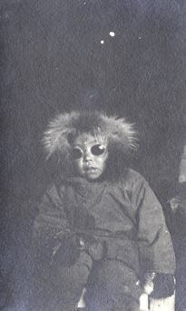

The photographs from Nita’s early days among the Norwegians show something of the way she was and how the Norwegians perceived her. Once she had got over her first encounter with the world on the Maud, Nita proved to be active and extrovert. In the pictures, she was always busy with something; she was active and inquisitive. Even in the pictures where she has been posed, she seems to want to move about, as little children generally do after a while when a photographer has asked them to stay still. Her head was turned towards new things to be seen, her mouth was always trying to say something.

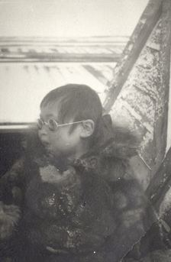

A fair number of photographs taken by the crew during the Maud expedition have been preserved and Nita was one of the most frequent subjects from 1921 onwards. These pictures are reminiscent of family photos; the kind that are taken simply for the family’s own use and pleasure. At the same time, they were taken by men who routinely took photographs because they knew they must document the voyage for the benefit of a fascinated, paying public. Every picture may have been taken for the people living together – for her and the others on board the Maud. But they may also have been taken with the public in mind, those people living on the other side of the globe who would also get to see them later.
Some of the photographs were taken out on the ice. These emphasized how small she was – a little dot of energy in all that white desolation. In one of the pictures she is holding one of the weather balloons Sverdrup used for upper-air observations. If she lets go of the balloon, it will disappear up into the air. There are things that are not birds and yet can fly; things people have made and put in her hands, telling her to hold on tight so they do not disappear.

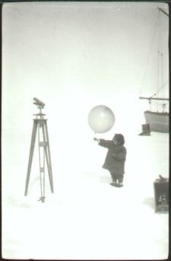

She was something to look at, something to talk about and eventually somebody to talk to once she began to learn Norwegian words. The contact with Nita resembled the contact Amundsen and the Norwegians had long had with the indigenous peoples of the polar region. She was an exotic and entertaining element who simultaneously offered entirely new opportunities for human contact. For Amundsen, she offered an occasion to win back a feeling of responsibility and control, as well as to display concern. This made it possible to resolve the deadlocked, conflictive behaviour patterns that had set in among the men on the ship. While the ice around the Maud caused a physical stagnation, the men on the ship had also got stuck; Nita created movement.
Amundsen kept a journal on the Maud. When Nita was brought on board, she also entered his journal. The sentences about her rapidly acquired an air of concern; they stood out from Amundsen’s sober entries about the weather, ice and other practical matters, just as the little girl stood out among the men on the ship. It appears that the two of them rapidly became attached to one another. In Amundsen’s journal, it emerges that Amundsen got her to call him “bettepappa” – “Granda”. Harald Ulrik Sverdrup also wrote down his impressions of this time and emphasized the close and familiar relationship that built up between Nita and Amundsen. To illustrate this Sverdrup told an anecdote:

It was touching to see the devotion she displayed towards Captain Amundsen. Every morning he would take a walk lasting three-quarters of an hour, and when he walked, this little fur-wrapped bundle would totter along after him. Nita was not a fast walker, so when Amundsen was nearly home again, he would meet her on the way back and they would come on board again, hand in hand.

The anecdote highlighted the Nita who had such appeal for the Norwegians: small, active and charming. It also testifies to her devotion to Amundsen. But if we read this little everyday drama in light of what Nita went through before and after her time on the Maud, it becomes less innocent. The first time Amundsen went for his morning walk out on the ice, without turning around and without waiting for her, Nita had already experienced being abandoned by Kakot in the family tent when he travelled to the Maud to seek work. Then she experienced him handing her over to the Norwegians. Because Amundsen invariably returned, it is always possible to see this from Sverdrup’s perspective, as a tale of a touching reunion. But tomorrow was another day: once again, Amundsen would walk out across the ice, leaving her behind.
It is not easy to grasp that the relationship between two people may be coloured by both mutual human intimacy and stark difference. Yet this is how it seems to have been with these two. So many differences lay between them that could have divided them: age, sex, culture, ethnicity. Sverdrup’s anecdote shows how Nita could feel dependent on Amundsen’s attention, how she constantly strove to attract it. As for Amundsen’s own attitude, the anecdote suggests a certain nonchalance. He knew she simply had to put up with it; knew that she would be there, would put her hand in his when he came back.
Nita had a round face, big cheeks, narrow eyes and jet-black hair. “She’s a funny little kid – horribly ugly – terribly naughty, but extremely comic. We vie to spoil her,” wrote Amundsen in his journal. The difference made Amundsen feel free to express intimacy and condescension in the same breath. During the Northwest Passage expedition, Amundsen wrote of an Inuit man that he would have “been a beauty had not his broad face and large mouth spoilt his beauty according to our European tastes”. Amundsen and the other Norwegians had a tendency to categorize the appearance of the indigenous people along an axis that ran from somewhat attractive to downright ugly. What the Norwegians wrote about the indigenous people was often a striking blend of appreciation and condescension, sympathy and antipathy. The Norwegians were impressed by the natives’ skill when it came to mastery of nature and harvesting its fruits, but they could still hold forth on how slow they were to learn what Norwegians deemed to be abstract and advanced knowledge. In some cases, it was as if the Norwegians could sense their own ambivalence, like when the captain of the Maud described a visit to the Chukchi tents: “But what shall I say of these people, ignorant, primitive people who not only gave us passing strangers free board and lodging but also procured meat, blubber or fish for our dogs”.
The fact that the Norwegians could be condescending did not mean that they always felt in control. The natural world in Siberia was the indigenous people’s home territory; they had the means to master it that the Norwegians on the Maud lacked. On their way through the Northeast Passage, the Norwegians had to trade with the local people for food and furs; they needed information about weather and telegraph stations. It was practical to have contact, but when the Norwegians got to see and talk to people apart from their shipmates it also made an impression in other ways. Then they had somebody they could peer at, covertly or openly, to see what was the same and what was different from what they were used to. They could recognize themselves when an indigenous person tested the sharpness of a knife blade. These were people the Norwegians felt they could reach an understanding with now and again, albeit fleetingly; people who could unexpectedly laugh about the same things as them. Far from their home country, strong and surprising feelings of closeness for this stranger might unexpectedly appear. But these were generally mixed feelings, in which the genuinely intimate and positive co-existed with a sense of superiority, condescension, sometimes disdain.

*

When Kakot first came to the Maud in autumn 1920 seeking work aboard the ship, one of the traders they had contact with warned the Norwegians about him. He knew of Kakot from before and considered him lazy and incompetent. This seems not to have made any impression on Amundsen, who gave Kakot a job and appears to have been satisfied with him. Kakot chopped wood, washed up and eventually they trained him to cook. He had his own cabin, worked side by side with the Norwegians, ate with them and hunted with them. They also tried to teach him to count and write with less success. Sverdrup said Kakot struggled, and thought it was because Chukchi people weren’t suited to this kind of thing.
In mid-February 1921, Kakot asked for permission to go to the mainland to find a new wife. Amundsen agreed and sent Kakot off with gifts. The matter had probably been arranged through some kind of previous contact because Kakot came back the very next day with the news that he had a new Chukchi wife who would come to the Maud. She spent a good three weeks on the Maud before she and Kakot left the ship. All Amundsen writes about the woman is that she was a good worker, before commenting jovially on the physical contrast between the pair. She was apparently the tallest, most strapping Chukchi woman he had ever seen, whereas Kakot was small and frail. It was a condescending portrayal of what one could also see as an attempt on Kakot’s part to gain a foothold in life independent of the Norwegians.
Much of the Norwegians’ writing suggests they saw Kakot as a bit pitiable. A “little weakling” wrote Amundsen of Kakot, who was short. According to Sverdrup, Kakot had been a drifter before coming to the Maud. He didn’t go hunting on the ice with the others and owned no property. Sverdrup thought Amundsen took Kakot on board because he felt sorry for him. Whether or not that is the case, there is much to suggest that Kakot – and therefore Nita – had lived an exposed existence in the times before the Maud, somewhat apart from Chukchi society. In his time on board the ship, Kakot was also on the outside of the Norwegian community even though they lived close to one another day to day, and even though it would be unreasonable to say without reservations that the Norwegians treated him badly. He never learnt more than a few words of Norwegian and there was a limit to the Norwegians’ understanding of the Chukchi language. Kakot seems to have been well liked for his sociability, but he was only half-included, half-initiated, half-respected.
Perhaps this life, with one foot constantly outside the different societies, explains why Amundsen later wrote: “there was something about Kakot that made him always seem sad”. The picture of Kakot below was taken on board the Maud in April 1921. At that time, it was around four months since Amundsen had taken charge of Nita. Kakot had remained on the ship. He was a cabin boy and odd-job man, but no longer a father.

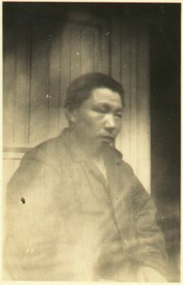

- Camilla

A sled track ran along the Chukotka coast. Everybody used it for travelling: Chukchi people and Westerners, adults and children. The track alternated between flat, open stretches and mountain ranges, where ridges like Cape Heartstone towered out to sea. Along the flat stretches, the track followed beaches of ice-covered pebbles and continued across the narrow sandbanks. Then it led up the mountainsides and inland through deep, everlasting snow before descending once again towards the sea. In winter, it was hard to follow the sled track: one hard blast of drifting snow and it was gone. In winter, some people took short cuts across the sea ice, where shattered ice floes and pressure ridges created confusing patterns. The travellers preferred the short summer months, when it was possible to follow an unbroken path over bare land. Any impressions left there could take years to disappear.
It was demanding terrain, exposed to the elements, but the sled track was the only option for travel and the most important place for meeting other people. This is where the reindeer-herding Chukchi came from the inland with their furs and hides. The coastal Chukchi transported bones and baleen from whales, walruses and, occasionally, mammoths. Traders from the West and Russia travelled along the sled track between their makeshift wooden houses with tea, sugar, tobacco, weapons and canned goods. Sometimes Western ships made their way in from the open sea, seeking and finding people along the track. They all met at the wooden houses and tents along route, sitting in the light, dense heat of the fish-oil lamps in the evenings as the wind tugged at the tent walls. They communicated in what little they had picked up of each other’s languages: English, Russian and Chukchi; or they spoke with hands and faces. Then they shared the pemmican and biscuits the traders had with them, or they ate the Chukchi food: fish, seal, walrus and reindeer. In this way, the Chukotka coast became a point of contact between people, a mingling of different ethnic groups. Along the sled track, a culture of hospitality had developed. If a stranger arrived, he was given board and lodging without being asked for anything in return other than news: where in the area were the merchant ships, how was it going with the Great War in Europe, what kind of people were these Bolsheviks, actually, who had just taken power over there in the west, in the big Russian cities?
The Western tradesmen were people who travelled long distances. Some of them were originally from Scandinavia, others from Great Britain, Canada and Alaska. The one who became the Norwegians’ closest collaborator was originally from Australia. Clarendon Coulson Carpendale, known as Charlie, left home as a young man and fought as a soldier in the Boer War in South Africa. Then he heard about the gold rush around the city of Nome in Alaska and travelled there in the first years of the 1900s. He found himself among a stream of enterprising, restless men who had followed the gold rushes north across the American continent, to the Klondike and then to Nome. Only a tiny minority grew rich from it and Carpendale was not among them. He was one of those peering west across the Bering Strait and thinking perhaps there was gold in Chukotka too. Nothing ever came of it, but the trading opportunities turned out to be good.
At the beginning of the 20th century, Chukotka was still part of Russia, although mostly in name. There were too few people at the heart of power in Moscow to reach across the enormous distances of the realm to the points furthest north and east. The Chukotka coast was less a part of the Russian nation than an international meeting place for peoples, cultures and languages. Whatever goods the indigenous Chukchi and Inuit people around the Bering Strait needed, they most often obtained from the Western traders who crossed the strait. Charlie Carpendale established himself at East Cape, just across the strait from Alaska. He built up a trading business in the area, became a Russian citizen and married a Chukchi woman called Pung-I Tonanik, who also went by the name of Jessie. Eventually, Carpendale had nine children with her, all of whom had Western names: Irma, Leo, Eva, Molly, John, Lily, Milly, Lola. And Camilla.

*

In winter, the Norwegians often travelled to Charlie Carpendale’s house in East Cape, and they maintained contact through letters carried to and from the Maud by people in his service. Carpendale supplied the Norwegians with provisions, new dogs and dog food, used his influence in the area to help them on their journeys and had winter clothes made for them. For the Norwegians, Carpendale was the ideal contact: Western enough to offer easy communication on equal terms and at the same time, a local big shot, with native contacts and influence. Carpendale sat at the centre of a network of reindeer-herding and coastal indigenous groups, sailors, sled-drivers, artisans and casual workers of many ethnicities and nationalities. Across the Bering Strait and along the shipping route in Chukotka he sent goods and people with information about prices and trading opportunities, weather forecasts, ships on their way across the strait and political gossip.
The Norwegians ended up exchanging not just goods and services with Carpendale, but a daughter too. Camilla came to the Maud on 19 April 1921, following an agreement between Carpendale and Amundsen that Camilla should be given a Western education. She would also be “company for Kakot’s daughter”, wrote Amundsen in his journal. He gave a brief description of the future he now envisaged for the two of them: “My intention is to send her home with Kakonita so they shall both be well brought up.”
It was Amundsen’s helper of many years’ standing, Oscar Wisting, who drove Camilla to the Maud by sled. At this time, she was 11 years old. Wisting later published an autobiographical account that was full of details of the trips he made to East Cape. Wisting wrote extensively about provisions, storms, the telegraph office and the need to reach it, as well as Chukchi customs and ways of life. This makes it all the more striking that he omitted everything we might now wish to know about Camilla at the time she was brought to the ship.
We can hardly assume from Wisting’s silence that Camilla was unimportant. Her significance was not then of a personal nature for the Norwegians. She was part of a larger trade between the Norwegians and Carpendale. The handover made sense for both parties. Amundsen needed company for Nita, somebody who could fill the role of big sister and help out. Even though he was an established trader, Carpendale, for his part, needed to relieve the burden of maintaining and bringing up nine children. Years of poor catches that caused famine among the Chukchi people could also make living conditions insecure for the traders. When the outcome was uncertain and the family large, it wasn’t especially unusual to send children away for a while.
All we know of Camilla’s feelings about the separation from her parents is what we can infer from Oscar Wisting’s account of the close-knit Carpendale family:

Carpendale was married to a native woman and their marriage is one of the most ideal I have seen. I am in no doubt that he held her in enormously high esteem and he had good reason to do so, too. (…) When I arrived, he went in to join her and the children, and nor have I seen a more beautiful relationship than between him and his children. They loved him above all else on Earth.

Camilla was taken from a loving home by a strange man, to be placed in the charge of yet another man she did not know. It is unclear whether she had been told when she would come back to her family, unclear whether anything had been said at that point about travelling to Norway. When Camilla was sitting in the back of Wisting’s dog sled on the way to the Maud and away from the familiar places of East Cape, she knew at least that she was embarking on a new life.
The cold was less harsh than in the January days when the youngest girl travelled along this coast; it was nearing zero degrees Celsius. The sled tracks were slushy and the going was tough. Here and there puddles of salt water lay on the ice, forcing the sled to steer around them. When spring comes in the sub-Arctic regions everything can still seem monotonous and unchanging at first glance. White snow lies just as heavily on land between black mountain peaks; grey ice lies dense as ever, piled up across the sea. But when you look more closely at things, everything is in motion. The ice crystals have begun to glisten and glide, little watery gurgles sound from the becks that are beginning to trickle between the earth and the snow cover. The distant calls of the eider duck and cormorant sound from the mountains that project into the sea along the coast and from the flatlands in between where flocks of geese roost. Far out on the ice-covered sea there is a crashing, a creaking, a thudding: sub-sea sounds of ice breaking up and picking up speed.
A low carpet of grass grows cautiously up around the track along the coast. Most of the year it is still cold enough that the green often bears a translucent layer of white in the mornings.

*

Camilla is said to have been big for her age. Her skin was darker than Nita’s but her features more Western. She was “a thoroughly sweet girl, quiet and calm and quite pretty besides,” wrote Amundsen in his journal. The Norwegians didn’t photograph her with the same eagerness they’d shown when it came to Nita. There are only a few pictures of Camilla from her time on the Maud. In two of the photographs, apparently taken on the same day, she was wearing clothes that may have been sent to her by the Carpendale family.
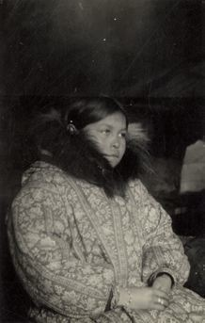

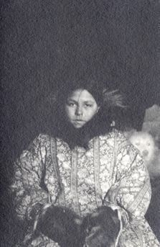

Camilla looks like that quiet, obedient girl Amundsen describes in his journal. It seems as if she could stay sitting like that for a long time if nobody told her she was allowed to get up. The two photographs cannot have been taken at precisely the same time, because Camilla is wearing gloves in one but not the other. That said, she sits in the same posture, with the same facial expression. Set side by side, the two photographs give the impression that she sat, motionless, allowing the camera to examine her the way an obedient child sits still for a doctor’s examination. Her gaze is remote in both pictures; whatever she is thinking, she seems to be holding it back.
It is often difficult to interpret people’s feelings in photographs. It is especially hard when the person portrayed appears to be holding back her feelings. At the same time, it is difficult not to wonder what it is stirring in the person in the picture, to whom we can get no proper access. Close-ups of faces are different from close-ups of, say, an arm or a foot. When we see such body parts, we generally look further, imagining the body excluded from the picture. If we see a face, we are driven to seek within, for the experiences and feelings we think may be hidden behind the features. “There is something in the face we cannot see,” the film theorist Bela Balász said about such pictures of faces, in an ambiguous formulation. The two pictures of Camilla are doubly closed to us. First, we are hindered by the fact that we do not know her; then by the way she is holding back. She appears to be looking at us in the photograph on the right, but then she isn’t really: her gaze is turned inwards, perhaps backwards in time too.
In the right-hand picture, a sled dog pokes its head out from behind Camilla, like one of those old trick photographs the spiritualists used, where spirits come into view, forms that appear to be paying a visit to the living when the flash goes off and the picture is taken. The dog, too, is looking at a place we cannot see.

*

In spring 1921, Amundsen decided that the expedition should split up. He would go on ahead with the girls, along the Chukotka coast, across the Bering Strait to Nome, West Alaska, and from there to Seattle. Once the ship was freed from the ice, the Maud would sail after them to undergo repairs in Seattle. Later, they would travel onwards to Norway. Amundsen was impatient to make contact with the outside world; he had plans to pursue and people to negotiate them with.
Amundsen’s journal said almost nothing about Camilla in the brief month between her arrival on the Maud and their departure for the Bering Strait. The sources are scanty, but it is possible that, in this time, she alternated between living on the Maud and with her family in East Cape. It appears that there was a fairly rapid division of roles between the two girls, which seemed to correspond to two different personalities. Amundsen described Nita as the active, lively one, while Camilla is supposed to have been passive and biddable.

The spirited little Nita has entirely taken command, but it looks as if things will go fairly well. The older girl is very quiet and calm and complies totally with the little one.

In other places, we can also read that the Norwegians saw Camilla as withdrawn and passive. It may have been a matter of personality, but her assigned responsibility as a stand-in big sister for Nita may also have had something to do with the matter. It is fairly certain that Camilla’s social position – new on board the Maud, unaccustomed to being among Norwegians and unfamiliar with their language – played a role too. The girl’s mother tongue was Chukchi, a language unrelated to those of northern Europe. It is possible Camilla had picked up some English words from her Australian father and Harald Ulrik Sverdrup had a fair command of Chukchi. Nonetheless, there is much to suggest that the people on board the Maud mostly spoke in Norwegian.
It must have been a momentous transition for both of them: a new world on the ship, unknown people and a totally new language to master. At the same time, it is different to experience this kind of shift in world and language at Nita’s age than to do so when you are approaching the transition from childhood to youth. Camilla was better placed than Nita to discern that the entry into the Norwegian world also meant that the Chukchi, childhood world she had lived in up until then would be taken from her, along with the words she had applied to it. In spring 1921, Camilla was between two worlds. The one she understood, she had been obliged to leave. The one she must now live in was a mountain and she was only standing at its foot. At that time, Amundsen was apparently nowhere near as emotionally engaged with her as with Nita. He wrote little about her in his journal. When Amundsen left the ice with the girls, he sent a letter to his friend Fredrik Herman Gade and told him about the time the Maud had been locked into the ice by Cape Heartstone. The letter has not been preserved, but Amundsen must have emphasized Nita’s role, because in his reply, Gade was amazed that Amundsen had “got a daughter”. About Camilla, there was nothing. She had good reason to be quiet.

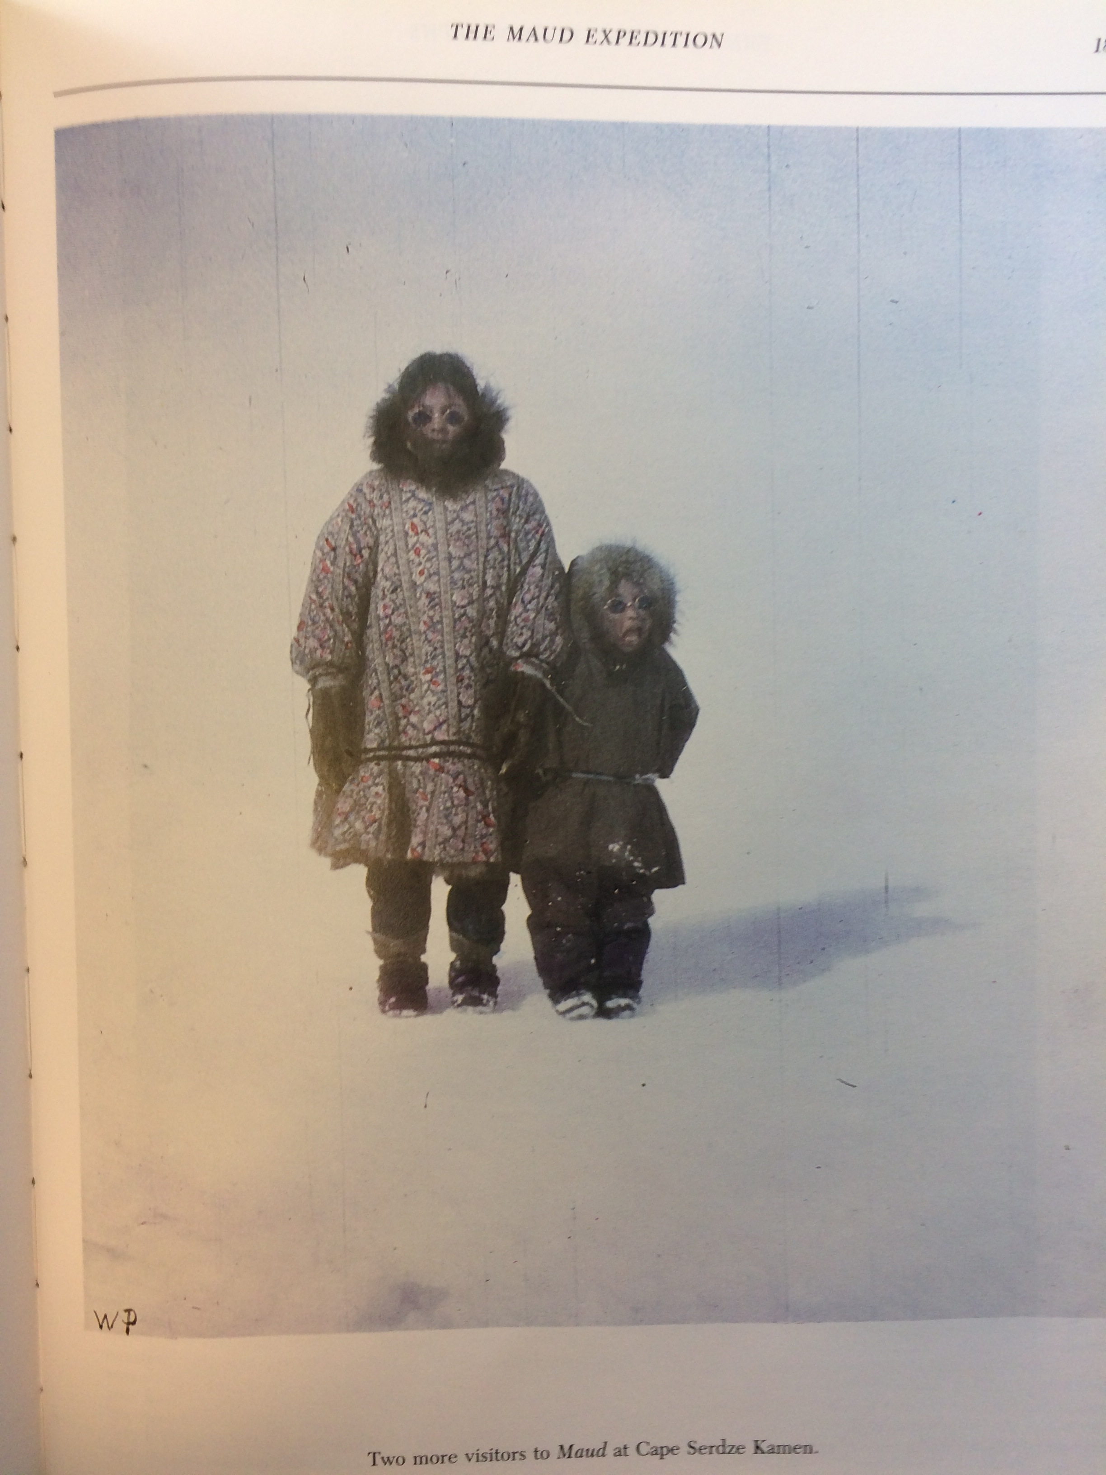

5. Maniratcha, Talurnakto, Tonnich, Kaumallo
Why did Amundsen take charge of Camilla and Nita? Why would he take them all the way across the globe to Norway? In the most important biography to date, Tor Bomann-Larsen tried to explain what happened based on Amundsen’s psyche. The starting point was that Amundsen prioritized Arctic conquests over intimate relationships. He was constantly setting off on new expeditions throughout his life, thereby distancing himself from a steady stream of new lovers and, increasingly, falling out with his family. This made him lonely, but then Nita arrived and satisfied Amundsen’s need for human intimacy, according to Bomann-Larsen.
The thought of the child’s warmth melting the iceman’s heart may be a tempting cliché to apply to events. But to say that Amundsen prioritized his career, that he could be domineering and display little consideration for his family is not to say much more than that he was a fairly typical Western alpha male of the early 20th century. Some very different factors beyond the depths of Amundsen’s heart and his inner pain came into play when he took charge of the girls. Nita and Camilla were not the first indigenous people from northern climes Amundsen had planned to take under his daily care; they were, respectively, the fifth and sixth.
When he began to think about how to take the two girls home with him, it wasn’t the first time Amundsen had laid plans to bring indigenous people from the north back with him to civilization either. He had already done it fifteen years earlier, when he led his first expedition through the Northwest Passage on the Gjøa in 1903-05, from Hudson Bay in east Canada to Alaska. Those plans had run aground after a fatal accident that occurred towards the end of the expedition, near the place where the border between Alaska and Canada runs into the Arctic Ocean. There lies the bare, flat Herschel Island. Between the south side of the island and the mainland, the sea is clear of ice in the summer. Then flocks of ducks fly through the sound on their way to the summer nesting grounds, the short, sharp flap of their wings whirring in the air. On 21 July 1905, Roald Amundsen was on board the Gjøa, which lay at the mouth of the Herschel Sound. Earlier that day, the Inuit man, Maniratcha, had left the Gjøa to row a canvas boat among the drifting ice floes in the sound to hunt for ducks. Maniratcha was 18 and had, at that time, been living for nearly a year on board the Gjøa. At one point, Amundsen also set out across the sound in a small boat to reconnoitre the channel further west. Maniratcha passed him at a fair distance. Amundsen called out from his boat, but it was blowy and he couldn’t hear the answer over the wind. Maniratcha was seen by the Norwegians on the Gjøa for the last time shortly afterwards, standing in the boat some way out in the sound, peering after a flock of ducks. Later, the Norwegians assumed that the gale and the waves tipped Maniratcha out of the boat. Like most Inuit people in those days, he could not swim.
At the time when Maniratcha drowned, the Gjøa was just days away from reaching Alaska and completing its voyage through the Northwest Passage. The accident ruined a plan Amundsen had long been mulling: he had been considering taking Maniratcha with him out of Inuit country. “It was a heavy blow for us all to lose Manni in this way,” Amundsen wrote later in his book, The Northwest Passage. “We had all become fond of him and it would have been of great interest to take him with us to civilized parts and see what might become of him…” Here, too, ambivalence crept into what Amundsen wrote. On the one hand, the declaration of human intimacy; and simultaneously, the planning of what resembles an experiment carried out on the same human being.
Of Maniratcha’s background and his biological parents we know nothing. Amundsen’s descriptions in The Northwest Passage provide limited information. According to him, Maniratcha lived with an Inuit foster father who gave him up in exchange for a file and an old knife. Maniratcha came on board, was washed, doused in insect powder to kill the lice and dressed in the Norwegians’ cast-offs. In other words, he was given more or less the same treatment as Nita. “He won all hearts from the very first moment,” Amundsen wrote of Maniratcha. The man they called Manni lived on the Gjøa throughout one over-wintering, wearing Norwegian clothes, learning to use a rifle, cleaning up, chopping wood and fetching water. He visited the Inuit tribes with the Norwegians and dressed like them, he played cards with them, learnt to tell the time from them and caught cold when they did. Amundsen described him as a happy, pleasant youth. In spring 1905 Maniratcha apparently displayed interest in returning to his Inuit life and spent a short period living away from the Gjøa; but he wasn’t happy and came back again.
By the time Maniratcha came on board the Gjøa, Amundsen had occupied himself for a good while with thoughts of taking a native back with him to civilization. Maniratcha came on board to replace an Inuit man called Tonnich, for whom similar plans were laid. Before that, again, a man called Talurnakto had lived on the Gjøa and had been considered for the role of an Inuit in civilization. The plan was apparently to take an Inuit to Norway, let him speak to a language expert, produce a report on various aspects of Inuit life and then return him to his tribe in Canada. The procedure was akin to that used in ethnography, a science that was establishing itself at that time.
While sailing through the Northwest Passage, the Gjøa’s crew was in constant contact with different Inuit communities. They visited the ship to trade furs and hides for metal and wood, out of curiosity and sometimes to beg. The Norwegians, for their part, sometimes needed help with work and it was also practical to have an Inuit on board who could communicate with the local population when they sailed into new and unknown areas. According to Amundsen, the Inuit people they took on board were the ones to suggest the idea of accompanying them to Norway. Talurnakto and Tonnich were described pretty much in this way by Amundsen: they came on board because they were the Inuit people who were most interested in the Norwegians and then they developed a desire to accompany them back to where they came from. Then gradually, both had lost their motivation, Amundsen reported, but he wrote little and vaguely about why. In one case where he was concrete, the little anecdote he recounted raised more questions than it settled. According to Amundsen, Talurnakto lost any desire to travel to the white men’s land when the Norwegians showed him some pictures of the Boer War, which had just been fought in South Africa. Talurnakto was apparently so terrified by the violence in the pictures that he believed he would be killed in the land of the whites. Helmer Hanssen, for his part, told an anecdote whose starting point was that the Norwegians had ceased to see Talurnakto as a good candidate for a trip to Norway. Apparently they cured him of his desire to go to Norway by telling him that he risked being stuffed like an animal if he went with them. It is difficult to say whether Hanssen appears in a worse light if the anecdote is true or invented.
The most striking parallel with Nita during Amundsen’s time sailing through the Northwest Passage was Kaumallo, an Inuit boy of around 10 whom Amundsen took on board for a short time in 1904. Kaumallo was an orphan and had several physical ailments, including rheumatism. Like Maniratcha and Nita after him, he was cleaned up and had a haircut; like them he was given new clothes, his own bunk and food. But Kaumallo’s belly had difficulty adapting to the new fare, so they put him on a diet of oatmeal. “And by this he was mightily offended,” Amundsen wrote. “In the end, he refused to eat. As matters stood, I had no choice but to send him back ashore again. The next day he was just as filthy and horrible as before. But he was apparently much happier.” This was all Amundsen wrote about Kaumallo, who came on board and disappeared over less than one page of The Northwest Passage.
Since his death, Amundsen has been criticized for his dealings with the Inuit people during the Gjøa expedition. Poorly documented claims have emerged that he had sex with them and had children. It is possible to criticize Amundsen for less speculative activities, which are, moreover, easier to document. There is something undeniably ruthless about this business of taking indigenous people on board, letting them stay there for a while and then constantly replacing them with new candidates for the role of the Inuit in civilization. At the same time, the perception of Western upbringing as a privilege was far from unique to Amundsen in those days, and the same went for his tendency to think in terms of scientific experiments. Both were quite typical of the times, of the mentality of colonialism and early ethnography. The Westerners’ sense of representing a superior society helped them feel free to move indigenous people around. Belief in scientific procedures made it possible to assume an observer’s attitude towards events – at times, at least. There was an element of pseudo-scientific experimentation in the idea of exposing an Inuit to civilization so that Norwegians could “see what would become of him”, as Amundsen put it. At the same time, it was true enough that the Inuit people concerned were given an unusual opportunity to experience a different and bigger world. If, like Amundsen, one viewed the life of the indigenous people as limited and believed Western life offered superior opportunities, it could make sense to remove natives from their own milieu, in order to give them an upbringing and education in the West.

*

Amundsen’s decision to take charge of Nita and Camilla was a result of broad currents of thought in the inter-war years; of the colonial and scientific ideas then prevalent. It was also a product of the notion that living in Norway and going to school there would be a self-evident privilege for the girls. Indirectly, Amundsen’s decision to take the girls on was an expression of a strong faith in a Western bourgeois upbringing.
These ideals were under development in the period between the wars and were much discussed. The goals of bourgeois upbringing in the 1800s did not include making children feel they were unconditionally loved. Then, children were supposed to be virtuous, industrious and obedient in order to earn their parents’ love. They should be unassuming and self-reliant, rather than clingy and complaining. By the beginning of the 1900s, the idea of the virtuous child had been supplemented by the ideals of medical science: robust and vigorous children. Caring for children meant seeing to it that they were healthy, hearty and strong, able to deal with whatever life might throw at them. This brings us to the underlying reason why the idea of taking children from their biological parents and moving them across the globe could strike Amundsen as responsible. The assumption was that he would ensure they became like him: frugal, hearty and robust.
In the period between the wars, the competing ideal of the happy child gradually emerged in child rearing. It was actively promoted by the child psychologists of the day. Among them was Nic Waal, who wrote in 1937: “All of us who have children ourselves surely hope in our hearts that children will grow up happier and more spiritually healthy people than our own generation”. This way of talking about child rearing was not as widespread in the period between the wars as it is today, when it has become quite normal. We generally view the child’s nature as innately good, in the sense that it should not be suppressed but allowed to blossom. We also perceive it as vitally important for children to be emotionally happy, with themselves and others. Parents have reason to be happy if their child is happy, otherwise not. The strong demands for emotional closeness to the child make it more natural to think that the adults must also be physically present. It is easier to send children away if they are to be strong and healthy; children who are supposed to be happy must be kept close.
Amundsen was a man of the interwar period, not least in that he lived somewhere between traditional beliefs in the virtuous and robust child and the notion that the child should, first and foremost, be “spiritually sound”, as Nic Waal put it. The everyday care he showed Nita and Camilla on board the Maud testifies that Amundsen thought they should be happy and feel loved. He seems to have been fond of Nita, later of Camilla, for some simple reasons all of us can recognize: it warmed him when he saw them again. He was happy when they were happy. He noticed their affection and the effect it had on him. Amundsen’s decision to take charge of Nita at New Year in 1921 was the story of an emotional bond that developed rapidly and grew strong. Six weeks after she came on board, Amundsen wrote in his journal that Kakot had conducted a successful courtship among the local Chukchi people. He would have a new wife, giving Nita a potential stepmother. Nothing came of it, but the episode may have prompted Amundsen to declare in writing, for the first time, that he intended to adopt Nita and become her foster father. The reason he gave was love, of the kind that cannot contemplate the thought of separation: “I have become fond of her and would rather not see her in the hands of a stepmother.”
There are several such unambiguous declarations of love in the journal of that time: “Kakonitta – my little foster-daughter – is now quite devoted to mee. I believe she loves her ‘Granda’”. Amundsen’s phonetic way of writing may seem misplaced when he writes about sled equipment or temperature measurements, but its somewhat childish feel can create an almost touching impression when it is Nita he is writing about. “I am very fond of hur and shee of mee.”

Nita and Amundsen left the Maud with a vital and strongly emotional bond. Eventually, this would encompass Camilla too, even though her starting point was different. Such bonds between people are a genuine force in life, but they can be worn down and broken. Because they arise and play out in social contexts, they are vulnerable to changes and pressure from the environment. When Amundsen moved the girls across the globe, he simultaneously placed the bonds between them under pressure.

Notes (page references to be provided)

Part 1

Chapter: Cape Heartstone
On the journey of the father and the younger girl along the coast, and the girl’s condition, see Harald Ulrik Sverdrup, 1926, p.19-22; Roald Amundsen, 1927, p. 93-4.

The detail that Kakot supposedly came from Neshkan is found in the autobiography of the painter, A.A. Yakovlev, http://odynokiy.livejournal.com/2424786.html. Amundsen estimated in his journal (1546, entry 19 February 1921) that Nita’s mother died five years earlier, ie in the first year of Nita’s life.

The description of the tent environment and the traditional way of life among the coastal Chukchi people is based on Sverdrup, 1921, on the description of traditional Chukchi life in Rytcheu, 2003, and on Forsyth, 1992, p. 69ff.

Photograph: Kakonita asleep in Amundsen’s cabin. 1921, unknown photographer. NB NPRA 3030, Roald Amundsen picture collection.

Photograph: “Cape Serdtse-Kamen, spring 1921”. Photographer Harald Ulrik Sverdrup. Reproduced in Sverdrup, 1926, p. 216.

Still photograph of the sandbank in the sea off the coast of Chukotka, 1:17:56 from Med Maud over polhavet. NB DVD “Roald Amundsen Maud-ekspedisjon 1922-1925”.

Chapter 2 Amundsen

The quote by Fridtjof Nansen is from Nansen 1930, p. 82. The descriptions of the Northeast Passage expedition up until January 1921 largely follow the two central, recent Amundsen biographies: Bomann-Larsen, 2011; Wisting, 2011.

The point about the erasure of time and space comes from James Carey, 1992, p. 207.

Photograph: “Roald Amundsen looks out across the ice from the Maud. 17.07.1920. Unknown photographer. NB NPRA 2071, Roald Amundsen picture collection.

“If I had only ...”, Letter from Roald to Leon Amundsen, reproduced in Bomann-Larsen, 2011, p. 280-1.

The quotations referring to death are from Amundsen, 1921, p. 192, and Nansen, 1930, p. 313.

Chapter 3 Nita

“… loud-voiced people deep within it”, Harper, 2000, p. 3.

The description of when Nita came on board the Maud is based on Amundsen, Mitt liv som polarforsker, p. 93-4 (including the highlighted quotation); Amundsen, Dagbøker 1920/21, entries for 2/1 and 4/1 1921; Sverdrup, 1926, p. 21 (including the quotation).

“... seemed glad to be rid of her”, The Evening World, 10 January 1922. “... most fervently ...”, Aftenposten 09/19/1922.

“She had a name ...”, Sverdrup, 1926, p. 31.

Photograph, Nita in the clothes the Norwegians had made, unknown photographer, 1921. NB NPRA 3032, Roald Amundsen picture collection.

Photograph, Nita on the deck of the Maud, unknown photographer, 1921. NB NPRA3033, Roald Amundsen picture archive.

Photograph, Nita with weather balloon, unknown photographer, 15/05/1921. NB NPRA 2153, Roald Amundsen picture collection.

“It was touching ...”, Sverdrup, 1926, p. 31.

“She’s a funny little kid...”, Amundsen, Dagbok 20/21, entry 21/01/1921.

“... been a beauty ...”, Amundsen, 1907, p. 170.

“But what shall I say...”, Hanssen, 1941, p. 128-9.

“...little weakling”, Dagbok 20/21, entry 27/2. In addition to Amundsen’s journal, the description of Kakot is also based on Sverdrup, 1926, p. 20ff, and Amundsen, 2927, p. 93ff.

“... always seem sad.”, Amundsen 1927, p. 103

Photograph: Kakot, unknown photographer, 19/04/1921. NB NPRA2118, Roald Amundsen picture archive.

Chapter 4 Camilla

The descriptions of the sleigh track around Chukotka are based on Wisting, 1930, and especially Sverdrup, 1926.

Details about the traders in Chukotka in the early 20th century are taken from Forsyth, 1992, Sablin, 2013 and Yarzutkina (undated). Charlie Carpendale also went by the names of Clarendon Charles Carpendale and Clarendon Coulson Carpendale. The details about his life are drawn from the genealogy website Ocotilloroad.

“... company for Kakot’s daughter ...”, Amundsen, 1927, p. 94.

“Carpendale was married ...”, Wisting, 1930, p. 117.

Two photographs of Camilla Carpendale on the Maud, unknown photographer, 1921. NB NPRA 3035 and 3036, Roald Amundsen picture archive.

“There is something in the face we cannot see”, Balász, edition?, p. 103. Translated by the author. The reflections on the two photographs of Camilla build on Balasz’s insights.

“The spirited little Nita...”, Amundsen, Dagbok 1920-21, entry 19/4.

Slides: Camilla and Nita. Reproduced in Huntford, 1987 p. 189. Alda Amundsen’s private collection.

“... got a daughter ...”, letter of 30 July 1921 from Fredrik Herman Gade to Roald Amundsen. MS Nor 2 (127), Houghton Library, Harvard University.

Chapter 5 Maniratcha, Talurnakto, Tonnich, Kaumallo

Tor Bomann-Larsen, 2011, p. 551. In the most recent Amundsen biography so far, Alexander Wisting expresses himself in this way, see Wisting, 2011, p. 365.

The main source for Amundsen’s plans to move Inuit people to Norway is Amundsen, 1907. “It was a heavy blow ...”, p. 286. “He won all hearts from the very first moment”, p. 215. “And by this he was...”, p129-30. The plan to move an Inuit person to Norway and then back is described in Hansen, 1912, p. 115. The anecdote about Talurnakto (whom Hanssen calls Dalonakto) is from Hanssen, 1941 p. 48f .

Claims that an Inuit man called Luke Iquallaq was Amundsen’s biological son, conceived during the Gjøa expedition in 1903-6, come, among others, from the Canadian documentary The Blinding Sea directed by George Tombs. The available archive material from the Gjøa expedition indicates that some members of the expedition may have had sex with Inuit women, but provide no concrete grounds for thinking that Amundsen was among them. As for the Maud expedition of 1918-21, there is no trace in the archive material of sexual contact between Norwegians and the locals, Chukchi or other.

“All of us ...”, Nic Waal quoted in Rudberg, 1983, p. 209. The presentation of historical ideals of a bourgeois upbringing is based on Rudberg’s book.

“I have become fond of her and would rather not...”, “I have become very fond of hur and shee of mee”, “Kakonita – my little ...”. Amundsen, Dagbok 1920/21, entries 20/2, 25/5 and 20/3.

