Ann-Marie de Lange: The Female Brain.
A neuroscientist's perspective on women's life stages

Short presentation:
Science built the model of the human brain on one assumption – that it was male.
Our brains are shaped by hormones, yet science has long ignored how profoundly this affects women.
In The Female Brain, cognitive neuroscientist and clinical psychologist Ann-Marie de Lange explores how hormonal rhythms sculpt the female brain across every stage of life, from puberty and the menstrual cycle to pregnancy, motherhood and menopause. Drawing on new research and personal stories, she reveals the astonishing adaptability of the female brain: how it grows stronger, more complex and more resilient through change, loss and transition.
Why do so many women experience brain fog, mood shifts or changes in memory and focus? What really happens inside the brain during pregnancy or menopause? De Lange challenges the long-standing medical bias built on male physiology, offering a new, evidence-based perspective on women’s neurological health.
Both enlightening and empowering, The Female Brain combines cutting-edge science with lived experience to show that women’s biology is not a limitation — it is a source of strength.

Target Audience:
The book is aimed at women of all ages, as well as healthcare professionals and others who seek deeper insight into women's brain health. Aligning with a gradually increasing focus on women's health in society, this book addresses a crucial need by offering scientifically based, accessible information that empowers women to make well-informed health choices.

Three Key Selling Points:
Presents new peer-reviewed brain research directly linked to women's life experiences.
Highlights female life stages that have long been overlooked and taboo.
The author is an internationally renowned brain researcher specializing in the female brain, holding a PhD in cognitive neuroscience and trained as a clinical psychologist.
In Summary:
New and vital research, presented in an accessible and exceptionally well-communicated popular science style, on a topic not previously covered, from an internationally recognized brain researcher.

Excerpt from the preface:
“When I was a graduate student in psychology, I held a preserved woman’s brain in my hands. It could be studied, weighed, measured. Every groove and fold mapped. But none of these measurements could tell us anything about who she had been, what she had thought, what she had felt. Even though life experiences, especially aging, had left physical traces in her brain, the context was missing: How had she experienced life? How had she handled different phases of life? What had she found joy in, and who had she grieved for?
I began to think about all the women around me. The experiences that had never been turned into data. The experiences that no one had asked about or researched. For the brain is more than a physical structure; it contains our life story in the form of thoughts, feelings, impressions, and memories. And it shapes itself in step with what we experience throughout our lives.
Puberty, the menstrual cycle, pregnancy, childbirth, miscarriage, menopause – these are experiences that bind women together across generations. The mood swings that come and go with the cycle. The intense alertness in the face of a newborn child – or the lonely grief when a budding life is lost. The brain fog or anxiety that suddenly appears in your 40s, without warning and without explanation. This is not imagination, it is neurobiology – the brain’s response to hormonal changes.”

Mention in connection with the award of a scholarship from Fritt Ord.
text: Henrik Pryser Libell
– The female brain is largely unexplored as a field of study.
This is according to brain researcher Ann-Marie de Lange, who heads the FemiLab research group at the University Hospital of Lausanne in Switzerland. She has a doctorate in cognitive neuroscience and specifically researches women's brain health throughout the life course.
De Lange has received support to write the script for a popular science book about the female brain based on this type of research.

– Recent research shows clear connections between hormonal changes and brain structure during puberty, the menstrual cycle, pregnancy and menopause. What happens in the brain during pregnancy, she says, is something that little was known about until the last couple of years.

Maternal instinct and menopause
– Dynamic brain changes can have an impact on women's mental health during pregnancy and after birth, and are also related to what we often call "maternal instinct" – the special bond that develops between mother and child, explains de Lange.
Another topic is menopause, with symptoms where many women do not receive the support they want in society due to a lack of knowledge and openness.
– I hope the book can help reduce the stigma associated with common health challenges.
Natural female processes, such as the menstrual cycle and menopause, have traditionally received little attention in public discourse. We must work towards a future where women's health is no longer so taboo, says de Lange. She also runs the podcast “Snakk om det”, which addresses several topics like this within women's health.
De Lange says women's health has historically been under-prioritized, and that there is therefore still much to catch up on in the research front.
– The fact that women's health has been overlooked in medical research and public debate has had many consequences. Among other things, women experience more side effects from medications and are more often misdiagnosed than men. Recent research also shows that women die more often from postoperative complications than male patients, and that women with cardiovascular disease are less likely to receive intensive care than men.
In FemiLab, de Lange and her research team use machine learning and advanced statistics on data sources such as brain imaging, biological data, genetics, psychosocial factors and health registries. Because there are differences between women and men – at least in the disease picture. For example, women have a higher risk of developing Alzheimer's disease than men, says the researcher, while men are more often affected by Parkinson's disease.
De Lange communicates useful knowledge to a wide audience. She has an agreement with Cappelen Damm, and publication is planned for 2026.

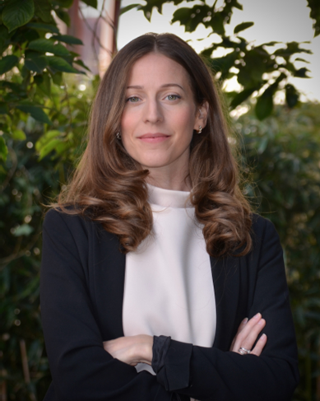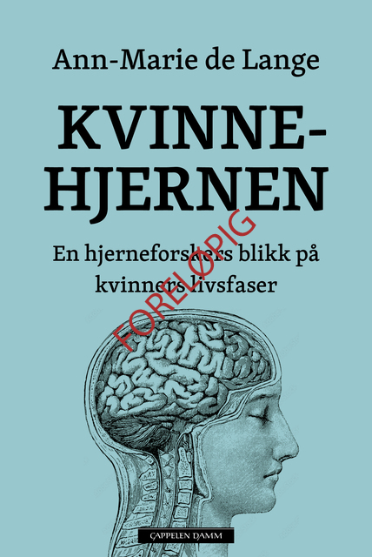

Ann-Marie de Lange is a neuroscientist and clinical psychologist specialising in population neuroscience and applied machine learning. With over ten years of research experience from the University of Oslo, the University of Oxford in the UK, and Lausanne University Hospital in Switzerland, she has a solid and internationally recognized academic background. As head of the research group 'FemiLab', she focuses on how biological, genetic, and environmental factors influence women's brain health throughout life. De Lange has published a number of influential articles and secured funding from research councils both in Norway and Europe. She has also worked actively to make research results available to a wider audience through podcasts, participation in a BBC documentary, and popular science talks such as TEDx.

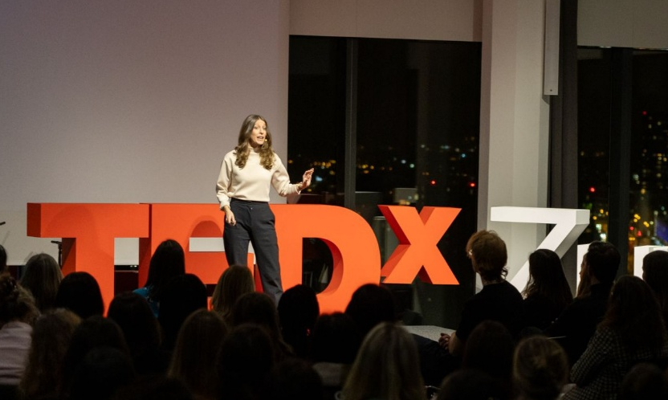

Ann-Marie de Lange leads the FemiLab research group at the University Hospital of Lausanne in Switzerland. Here she gives a TED Talk in Switzerland.

